Step 1: visit https://nvdpl.ca and under the “Read, Listen & Watch” tab, select “Ebooks & E-Reading”
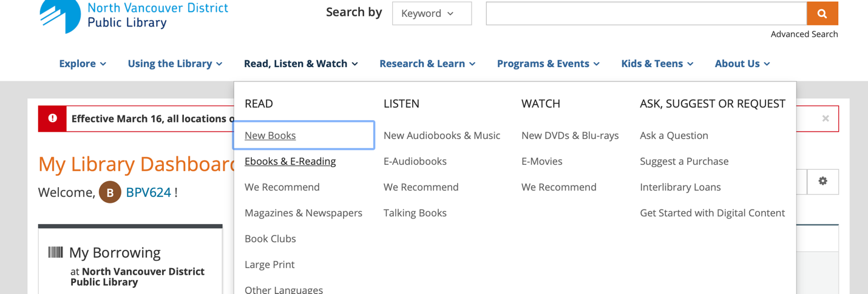

Step 2: scroll down, and under “Ebooks, E-Audiobooks & E-Comics”, click on the first link, “Library2Go”
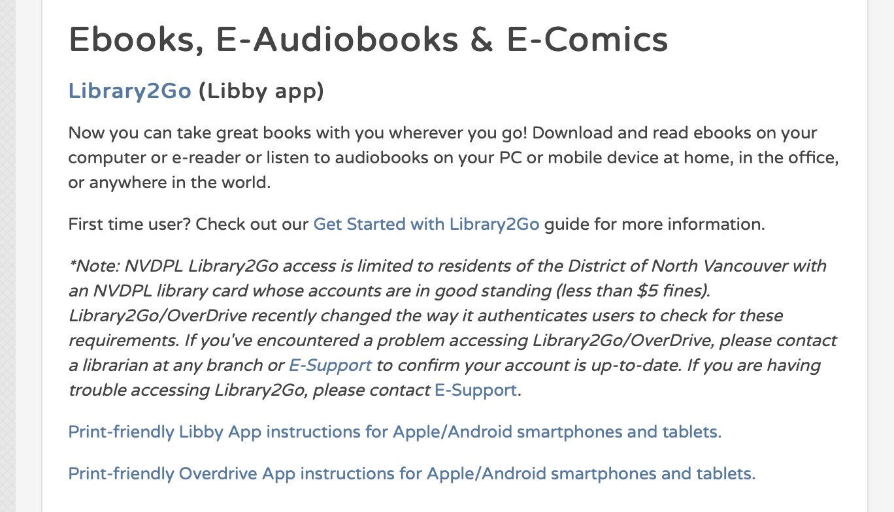

Step 3: select the “sign in” button on the right-hand side of the page
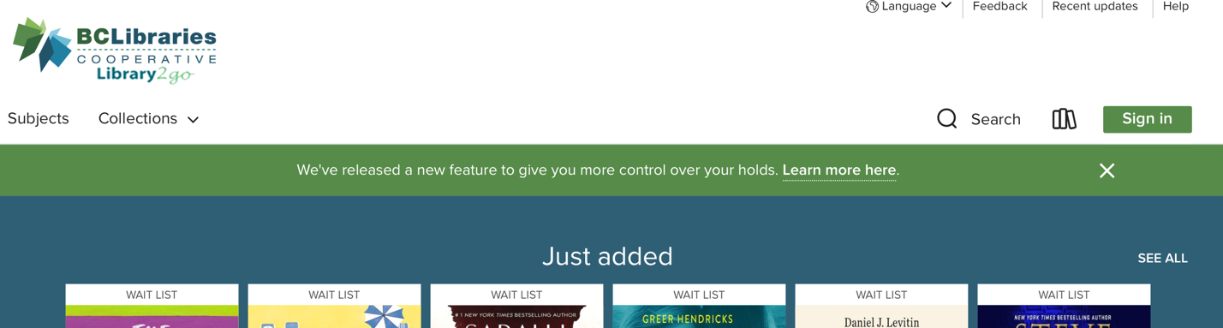

and then sign in using your library card number
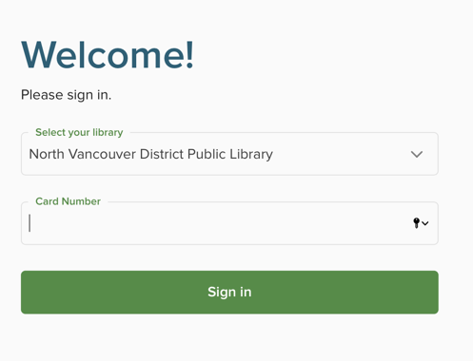

Step 4: now search some popular titles and get reading!
**borrowing ebooks and audiobooks from the library is similar to requesting physical copies, only a limited number of copies can be borrowed at a time.

Select “borrow” under the title you want, or “place a hold” if they aren’t available right now.

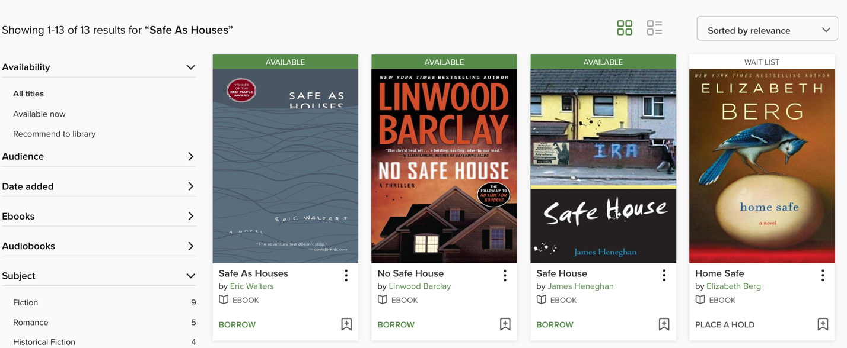

Step 5: select whether you would like a 7-, 14-, or 21-day rental, and select “borrow”
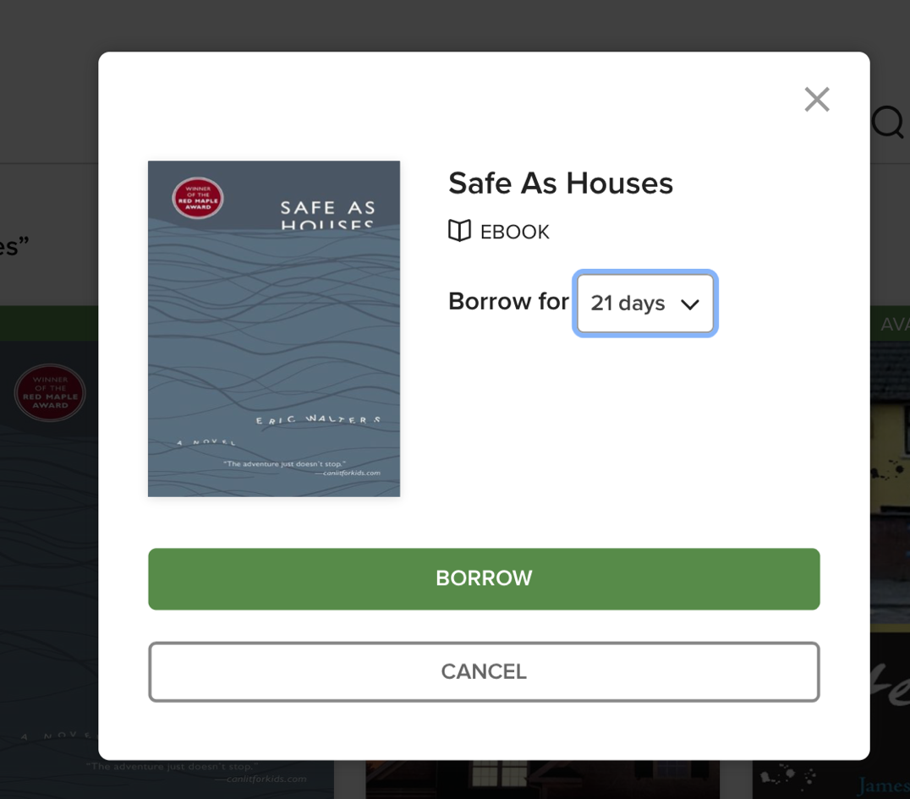
Step 6: you can either download the book to your laptop, or select “Read now in browser”
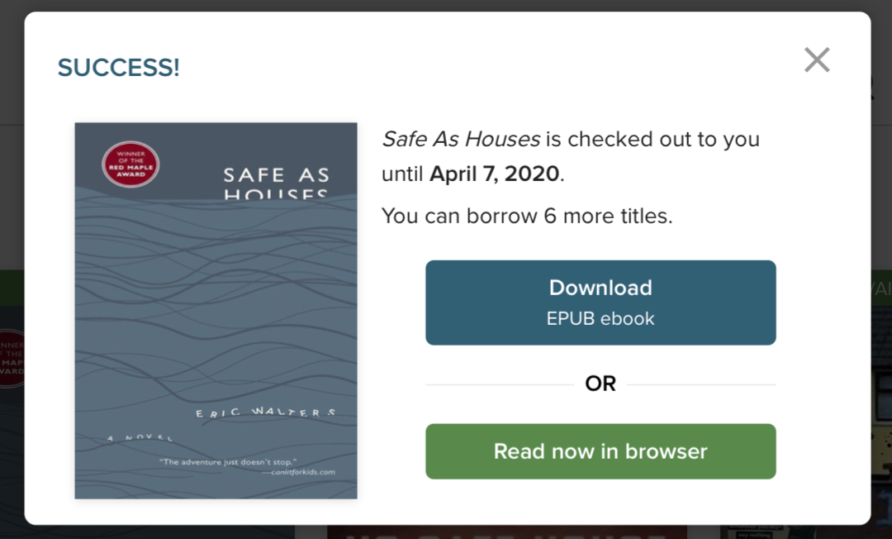

Step 7: you can turn pages by clicking on the sides of the browser, or by using your arrow keys.
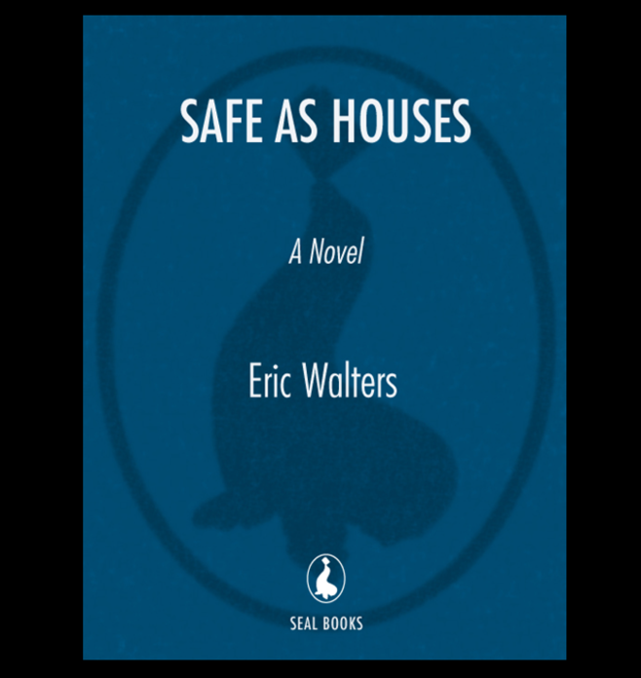
To change the settings, click on the center of your screen. The settings menu button will appear as three parallel lines in the right-hand corner.
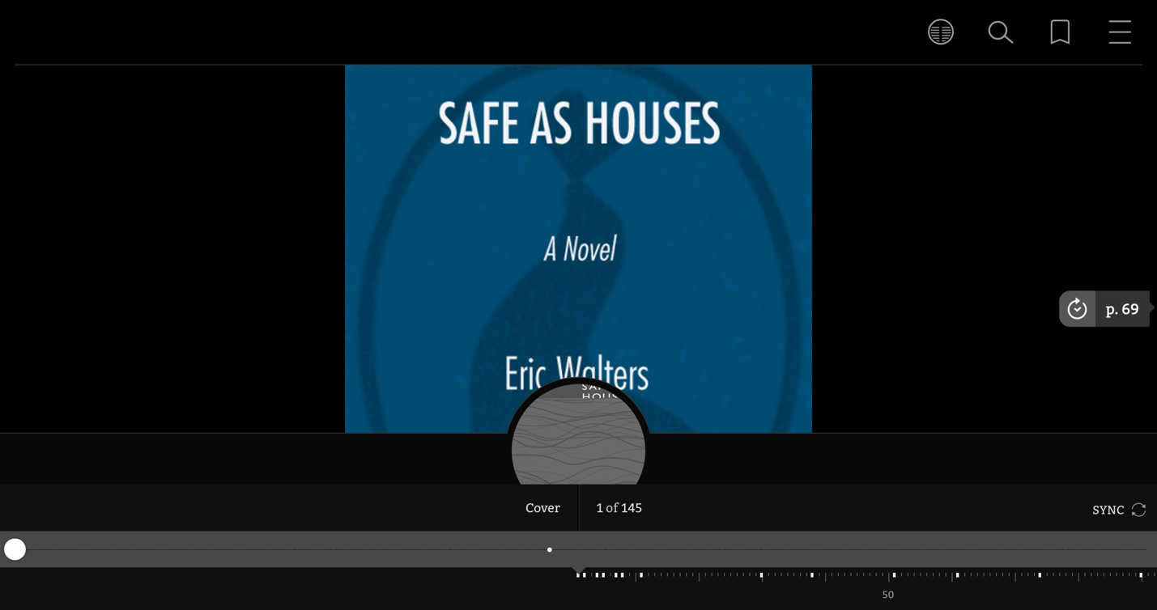
In these settings, you can view the book’s chapters, manage your bookmarks, change your reading settings (adjusting font, text size, lighting, and more!), and save the book to be viewed offline.
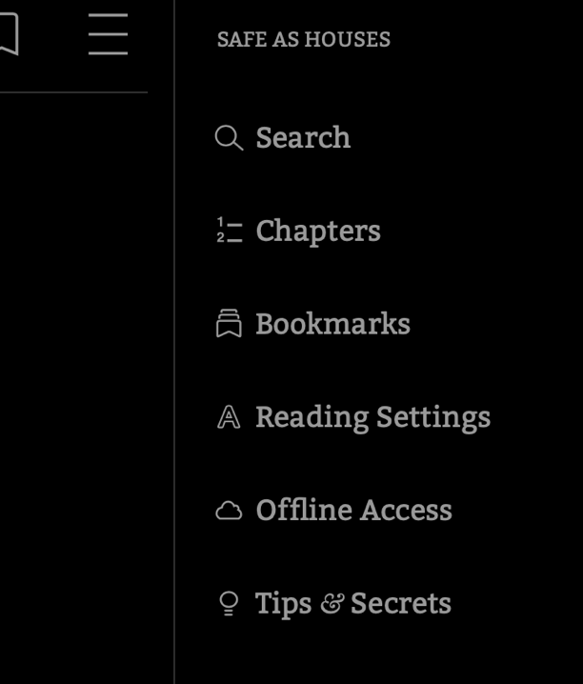
Step 8: once finished, return your book so that others can enjoy it!

