​​​​​​​​​​​​​​​
Community Supports for Young People and Their Families
​ | ​Foundry offers young people ages 12-24 health and wellness resources, services and supports – online and through integrated service centres in eight communities across BC.
​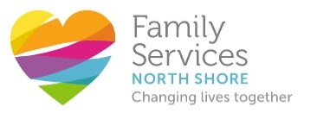 | Family Services of the North Shore is a non-profit, community-based agency.  For over 60 years, they have been committed to making deep and lasting impact across the entire North Shore, from Deep Cove to Bowen Island and every point in between.
​ | ​The Ministry of Child and Youth Mental Health (CYMH) offers a range of mental health services for children, youth and their families including assessment , treatment, counselling, groups, consultation and education.

