APPLIED SKILLS 8 WINDSOR SECONDARY

COURSE OUTLINE
INTRODUCTION

ADST 8 course meets the general aims of the Technology Education curriculum. https://curriculum.gov.bc.ca/curriculum/adst/8 Woodwork, Metal work, Electronics, Drafting, Power Technology, Engineering and Design, Robotics, Computer Drafting, plastic fabrication, and Art-Metal.

BIG IDEAS AND GENERAL LEARNING OUTCOMES
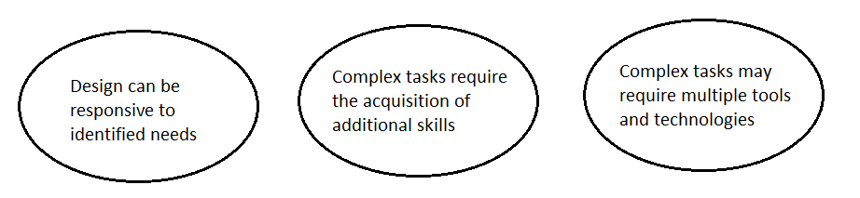
Students will be able to:
• understand how humans design and create using different types of materials, and the impact that these technologies have on our society, culture, and environment
• understand the range of careers possible in various technology fields.
• develop the ability to communicate through sketching, technical drawing, and graphics
• demonstrate skills in designing and developing artefacts using wood, plastic, and metal.
• demonstrate the correct, appropriate and safe use of hand tools, power tools and machines
• devise a production process and analyse material costing and product sharing
• describe the properties of wood, metal, plastics, adhesives, fasteners and hardware
• Identify and relate to “First Peoples” culture and heritage

COURSE CONTENT: REQUIRED LEARNING OUTCOMES

1. Technology and Society
● Origins and history of Applied Skills Technology
● Research and report on the purposes and uses of a variety of materials.
● Research and report on environmental issues and sustainability of materials.
● Identify designs and the needs factor for an ever-changing society.

2. Safety and Machine Theory
● General shop safety: safety sense, personal conduct, mindfulness, and responsibility
● General introduction to the correct and safe use of powered machines: in the wood, metal, electronics, and drafting labs.

3. General Theory
● Hand tools: emphasis on appropriate care, sharpening and precise use
● Gluing, clamping, adhesives, fasteners, welding, soldering, joinery and finishing techniques
●Computer generated images, measurement, and board drawing.

4. Project Processes and Procedures
● Overall design process in the production of several types of projects: using a variety of materials.
● Personal ideating: research, brainstorming, mind-maps, internet.
● Communicate ideas graphically: sketches, formal drawings, Computer Aided Drawings
● Construction and hands on project building
● Generate lists of materials and reuse and recycle materials when available
● Project sharing of ideas, pictures, sketches, within peer groups while developing project ideas.
● Identify the bigger picture of the design process which includes: Understanding context, defining ideating, prototyping, testing, making, and sharing.

STUDENT LEARNING ACTIVITIES

● Participate in general safety and theory lessons
● Research aspects of wood, wood technology, and wood as related to society and environment
● Produce and execute workable design solutions
● Engage in the planning and making of several projects

ASSESSMENT & EVALUATION

1. Theory - 15% - Quizzes, safety tests, exams, assignments
2. Practical Work - 70% - Projects, design portfolios
3. Social Responsibility - 15% - Safety sense, clean-up habits, accountability, student service

Teacher and Personal Self-Evaluations/Assessments are used to evaluate your ability to work effectively as an individual and collaboratively in a group, including your ability to share and maintain an efficient co-operative work space. You will be expected to reflect on your designs/projects with marking criteria.

EXPECTATIONS

Power Tools - Before using a power tool or machine the student must:
• Witness the demonstration
• Achieve at least 80% on the safety test
• Ask permission of the teacher
Safety - The technology department has a zero tolerance policy on violations of safety regulations
Attendance - This is an APPLIED course, ATTENDANCE IS MANDATORY
Shop Attire - Students should wear long pants and must wear safe footwear
- Students must not wear backpacks, outdoor clothing including hooded
sweatshirts, baggy clothing, jewellery including watches, personal headsets,
or any other electronic device
Project Completion - Open shop times are a privilege. It is expected that students who are behind in
their work will attend open shop periods.

** ALL PROJECT WORK MUST BE COMPLETED IN ORDER TO PASS THE COURSE **

Clean-up - All students are expected to actively participate in clean-up
Notebook - A notebook and a pencil and an eraser must be brought to every class

EQUIPMENT AND MATERIALS

Projects All materials and special equipment not covered in the course fee, and materials required for
extra credit project work must be paid for by the student

PARENT/GUARDIAN ACKNOWLEDGEMENT

I have read this course outline. I am aware of the course content, policies, expectations, student activities, evaluation procedures, and approximate costs.

Student Signature: __________________________ Date:_________________

Parent Signature: ____________________________Date:__________________

Tutorial Time and Schedule:

Tutorial Time is available each day from 8:30 AM – 9:15 AM Tuesday-Friday for those students that require extra time or help to finish projects and coursework. This time can also be used for special setups on tooling as required. The Woodwork Room is normally open at lunchtime during the week as well.

Please Note: Tutorial Time is drop in as needed and everyone is welcome. It is requested that students pre-arrange Tutorial Time with the Teacher, a short request in advance, in order to ensure the priority attention of the Teacher.

