COURSE OUTLINE
SUBJECT: Mathematics 9
BIG IDEAS:
The principles and processes underlying operations with numbers apply equally to algebraic situations and can be described and analyzed. |  | Computational fluency and flexibility with numbers extend to operations with rational numbers. |  | Continuous linear relationships can be identified and represented in many connected ways  to identify regularities and  make generalizations. |  | Similar shapes have proportional relationships that can be described, measured, and compared. |  | Analyzing the validity, reliability, and representation of data enables us to compare and interpret.

Curricular Competencies:
Students are expected to be able to do the following:
Reasoning and modelling
- Develop thinking strategies to solve puzzles and play games
- Explore, analyze, and apply mathematical ideas using reason, technology, and other tools
- Estimate reasonably and demonstrate fluent, flexible, and strategic thinking about number
- Model with mathematics in situational contexts
- Think creatively and with curiosity and wonder when exploring problems
Understanding and solving
- Develop, demonstrate, and apply conceptual understanding of mathematical ideas through play, story, inquiry, and problem solving
- Visualize to explore and illustrate mathematical concepts and relationships
- Apply flexible and strategic approaches to solve problems
- Solve problems with persistence and a positive disposition
- Engage in problem-solving experiences connected with place, story, cultural practices, and perspectives relevant to local First Peoples communities, the local community, and other cultures
Communicating and representing
- Explain and justify mathematical ideas and decisions in many ways
- Represent mathematical ideas in concrete, pictorial, and symbolic forms
- Use mathematical vocabulary and language to contribute to discussions in the classroom
- Take risks when offering ideas in classroom discourse

Connecting and reflecting
- Reflect on mathematical thinking
- Connect mathematical concepts with each other, other areas, and personal interests
- Use mistakes as opportunities to advance learning
- Incorporate First Peoples worldviews, perspectives, knowledge, and practices to make connections with mathematical concepts

CONTENT:
Students are expected to know the following:
- operations with rational numbers (addition, subtraction, multiplication, division, and order of operations)
- exponents and exponent laws with whole-number exponents
- operations with polynomials, of degree less than or equal to 2
- two-variable linear relations, using graphing, interpolation, and extrapolation
- multi-step one-variable linear equations
- spatial proportional reasoning
- statistics in society
- financial literacy — simple budgets and transactions
RESOURCE MATERIALS:
MathLinks 9 Pathways to Success (McGraw-Hill Education)
Direct entry scientific calculator required

The objective of the course is not simply to introduce certain mathematical concepts, but also to make you understand and be able to explain them to others. It should also help to improve your problem solving, analyzing, communicating and logical thinking skills. You will learn how to ask questions, to communicate mathematically, and how to present and verify your solutions.
I expect that you are a responsible and reflective learner. I expect that you will attend classes, complete the Check your Understanding assignments, and frequently check the course page on Microsoft Teams for updates and new information posted. The curricular competencies will be as important as the content in this course.
I expect that you come to class prepared, so that you can actively participate in problem solving activities during class time. I expect that you will work with your colleagues, share your ideas and ask questions. I expect that you will use the extra help during tutorial times as an additional resource if you need help with understanding the new concepts.
Being prepared for class includes working through the Check your Understanding questions and doing more questions from each page if needed. Reflecting on your work and identifying questions you need to ask is also part of the preparation.
I expect that you will invest as much time in this course as you need to prepare for class, complete assigned work, and reflect on your learning. It is recommended that you study on average 0.5 – 1 hour for each period of class time. This is an average time, and you may find that you don’t need that much or that you need more.

Assessment Categories | Focus
Unit Tests (units 1, 2, 3 and 4) | Content
Communicating/Representing **SA** | Collaboration and communicating thinking
Understanding/Solving | Problem solving within content
Reflecting/Connecting **SA** | Reflecting and learning from mistakes
Reasoning/Modeling | Problem solving in general

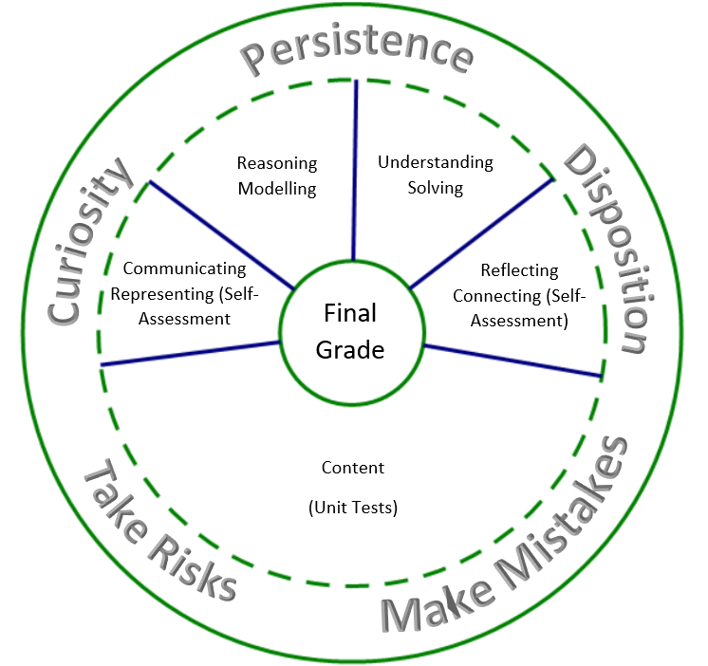

Class Notebook or OneNote will be used in this class as a digital portfolio for all of your work. Students should still be completing their assignments and practice with pencil and paper, but the work will need to be uploaded into the Class Notebook as a photo. The Class Notebook will contain the following sections
- Meaningful Notes: In this section, you will upload photographs of your completed Check your Understanding assignments, the daily reflection and notes that are important for you. There will be time provided in each class for you to reflect on your learning and insert photos of your board work or other work that you believe is important for your “future self.”
Group Quizzes and Exit Tickets are assessments that occur frequently and without warning. They are intended to give you an early indication of areas that you are having difficulty in and to reflect upon your growth with respect to communication and representing. A self-assessment for communicating and representing will be completed after each group quiz.

Unit Tests are assessments that happen only 4 times over the course of the term (once for each unit). Reflection on progress and corrections need to be made after every unit test. If you are not satisfied with your score on a unit test, you will be eligible for a re-write. See Mr. Pruner for details on the test re-write process.

Self-assessments will be used for assessing student growth within the indicated assessment categories (**SA**). Over the course of three self-assessments, students will be graded on their ability to identify areas requiring improvement and then demonstrating some progress towards these goals.

Ministry Link:
https://curriculum.gov.bc.ca/curriculum/mathematics/9

