Accessing Teams
There are two methods for logging into and accessing Microsoft Class Teams.

Accessing Teams via the school website.
Open a web browser and go to either the main SD44 website or your school’s website.
Click the (NVSD) Portal link.

Please contact your school if you do not know your login ID.
Enter your usual computer login ID (i.e. 0123231s) and your password. Click Sign In.

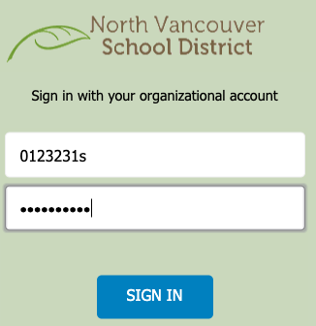
Your password is usually your birthdate in either the format “yyyymmdd” or “Syyyymmdd$”

Once logged in, ensure you are in My NVSD and click Teams on the horizontal menu bar.
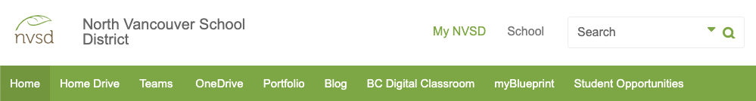

Accessing Teams via the Teams website
Go to https://teams.microsoft.com/

Login using your student login ID with “@sd44.ca” added to the end
(i.e. 0123231s@sd44.ca) and click Next.

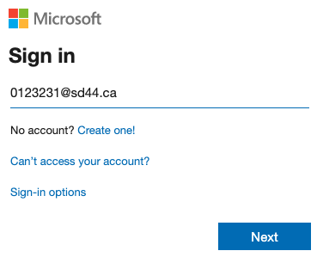

You will be re-directed to the SD44 login page. Enter your usual password and click Sign In.

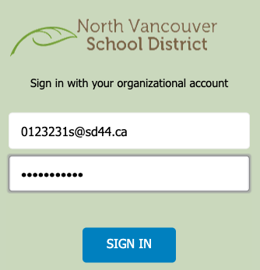

Joining a Team
There are three methods to join a Class Team

Join by Invitation
When your teacher or District administration creates a Class Team, you may be specifically invited. In this case, you will receive an email to your District account and the Team will automatically appear in your list of Teams. No action is required on your part.

Login to Teams to see the class and any associated content.

Join by Link
Alternatively, when a Team is created, your teacher may instead email you a direct link to the class. In this case, click the link to the class in your email, login to Teams (enter your District login information if prompted) and click Join.

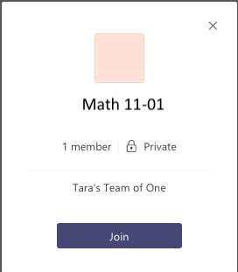

Access must be approved by the teacher so there may be a slight delay between when you Join and when the class appears in your Teams app.

Join by Code
Lastly, your teacher may instead choose to share an access code with you either via email or in person. To join via code, login to Microsoft Teams and click the Join or create a team link (this may appear in the upper right or lower left depending on your display preferences).

Enter the code provided and click Join Team.

Access to the team is instant (no additional teacher approval required).

