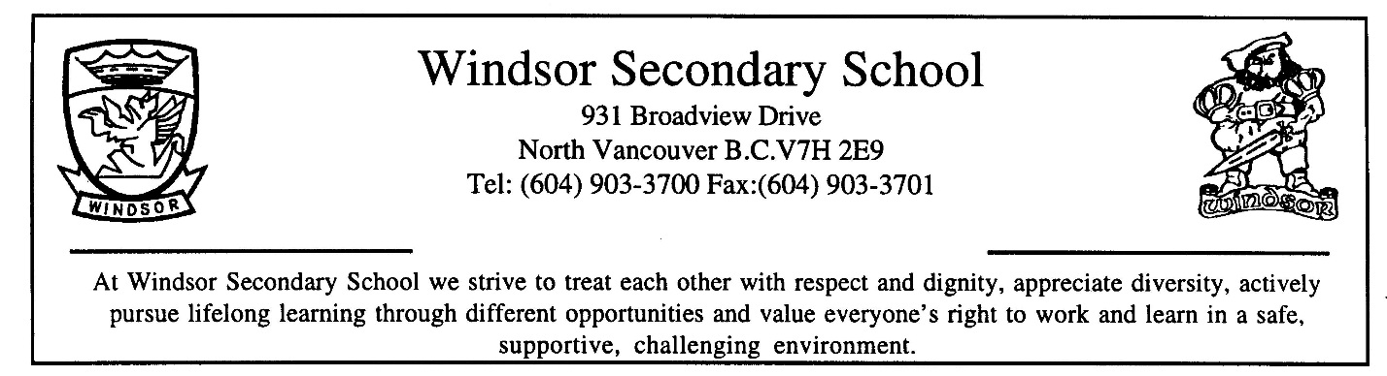

COURSE OUTLINE

SUBJECT: Pre-calculus 12

BIG IDEAS:

Using inverses is the foundation of solving equations and can be extended to relationships between functions. |  | Understanding the characteristics of families of functions allows us to model and understand relationships and to build connections between classes of functions. |  | Transformations of shapes extend to functions and relations in all of their representations.

Curricular Competencies:
Students are expected to be able to do the following:
Reasoning and modeling
- Develop thinking strategies to solve puzzles and play games
- Explore, analyze, and apply mathematical ideas using reason, technology, and other tools
- Estimate reasonably and demonstrate fluent, flexible, and strategic thinking about number
- Model with mathematics in situational contexts
- Think creatively and with curiosity and wonder when exploring problems
Understanding and solving
- Develop, demonstrate, and apply conceptual understanding of mathematical ideas through play, story, inquiry, and problem solving
- Visualize to explore and illustrate mathematical concepts and relationships
- Apply flexible and strategic approaches to solve problems
- Solve problems with persistence and a positive disposition
- Engage in problem-solving experiences connected with place, story, cultural practices, and perspectives relevant to local First Peoples communities, the local community, and other cultures
Communicating and representing
- Explain and justify mathematical ideas and decisions in many ways
- Represent mathematical ideas in concrete, pictorial, and symbolic forms
- Use mathematical vocabulary and language to contribute to discussions in the classroom
- Take risks when offering ideas in classroom discourse
Connecting and reflecting
- Reflect on mathematical thinking
- Connect mathematical concepts with each other, other areas, and personal interests
- Use mistakes as opportunities to advance learning
- Incorporate First Peoples worldviews, perspectives, knowledge, and practices to make connections with mathematical concepts
CONTENT:
Students are expected to know the following:
- transformations of functions and relations
- exponential functions and equations
- geometric sequences and series
- logarithms: operations, functions, and equations
- polynomial functions and equations
- rational functions
- trigonometry: functions, equations, and identities
RESOURCE MATERIALS:
Pre-calculus 12 Textbook
Locally developed supplemental packages
Scientific or Graphing Calculator required
MARKS ASSIGNMENT:
- 80% Coursework
- 20% Final Exam
POLICIES AND PROCEDURES:

  - PREPARATION FOR CLASS

It is the student’s responsibility to arrive for each class on time with their notebook, pencils, calculator, and textbook. Good work habits, effort, regular attendance, and completion of assignments contribute to successful achievement.

  - ABSENCES

Missing classes for any reason will have an impact on learning, assessment, and evaluation. Students absent from class, whether excused or unexcused, are solely responsible for obtaining and completing any missed assignments, work, or homework. Your teacher is not required to make special arrangements for unexcused absences.

a) Students absent for illness, medical appointments, and other emergencies must contact their teacher on the day they return to school to submit overdue assignments, schedule missed assessments, and to receive missed work.
b) Students absent for school related activities (ex. field trips, work experience, sports trips, etc.), must inform their teacher of this absence well in advance of the activity, in order to receive specific instructions on work that will be missed and the rescheduling of missed assessments.
c) Students absent for any other reason, including family vacations, are considered unexcused. Any work or assessments missed for these absences may result in receiving a zero for that activity.

_______________________ _______________________
(Student signature) (Parent / Guardian signature)

