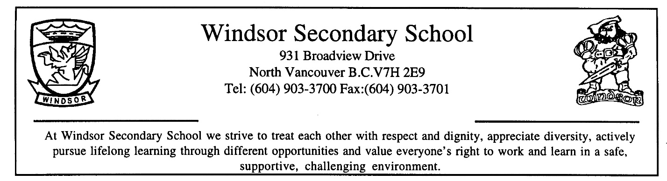

COURSE OUTLINE
SUBJECT: Mathematics 8
BIG IDEAS:
Number represents, describes, and compares the quantities of ratios, rates, and percent. |  | Computational fluency and flexibility extend to operations with fractions. |  | Discrete linear relationships can be represented in many connected ways and used to identify and make generalizations. |  | The relationship between surface area and volume of 3D objects can be used to describe, measure, and compare spatial relationships. |  | Analyzing data by determining averages is one way to make sense of large data sets and enables us to compare and interpret.

Curricular Competencies:
Students are expected to be able to do the following:
Reasoning and analyzing
- Use logic and patterns to solve puzzles and play games
- Use reasoning and logic to explore, analyze, and apply mathematical ideas
- Estimate reasonably
- Demonstrate and apply mental math strategies
- Use tools or technology to explore and create patterns and relationships, and test conjectures
- Model mathematics in contextualized experiences
Understanding and solving
- Apply multiple strategies to solve problems in both abstract and contextualized situations
- Develop, demonstrate, and apply mathematical understanding through play, inquiry, and problem solving
- Visualize to explore mathematical concepts
- Engage in problem-solving experiences that are connected to place, story, cultural practices, and perspectives relevant to local First Peoples communities, the local community, and other cultures
Communicating and representing
- Use mathematical vocabulary and language to contribute to mathematical discussions
- Explain and justify mathematical ideas and decisions
- Communicate mathematical thinking in many ways
- Represent mathematical ideas in concrete, pictorial, and symbolic forms
Connecting and reflecting
- Reflect on mathematical thinking
- Connect mathematical concepts to each other and to other areas and personal interests
- Use mathematical arguments to support personal choices
- Incorporate First Peoples worldviews and perspectives to make connections to mathematical concepts
CONTENT:
Students are expected to know the following:
- perfect squares and cubes
- square and cube roots
- percents less than 1 and greater than 100 (decimal and fractional percents)
- numerical proportional reasoning (rates, ratio, proportions, and percent)
- operations with fractions (addition, subtraction, multiplication, division, and order of operations)
- discrete linear relations (extended to larger numbers, limited to integers)
- expressions- writing and evaluating using substitution
- two-step equations with integer coefficients, constants, and solutions
- surface area and volume of regular solids, including triangular and other right prisms and cylinders
- Pythagorean theorem
- construction, views, and nets of 3D objects
- financial literacy — best buys
RESOURCE MATERIALS:
MathLinks 8 Pathways to Success (McGraw-Hill Education)
Locally developed supplemental packages
Direct entry scientific calculator required
POLICIES AND PROCEDURES:
  - PREPARATION FOR CLASS
It is the student’s responsibility to arrive for each class on time with their notebook, pencils, calculator, and textbook. Good work habits, effort, regular attendance, and completion of assignments contribute to successful achievement.

  - ABSENCES
Missing classes for any reason will have an impact on learning, assessment, and evaluation. Students absent from class, whether excused or unexcused, are solely responsible for obtaining and completing any missed assignments, work, or homework. Your teacher is not required to make special arrangements for unexcused absences.

      - Students absent for illness, medical appointments, and other emergencies must contact their teacher on the day they return to school to submit overdue assignments, schedule missed assessments, and to receive missed work.

      - Students absent for school related activities (ex. field trips, work experience, sports trips, etc.), must inform their teacher of this absence well in advance of the activity, in order to receive specific instructions on work that will be missed and the rescheduling of missed assessments.

      - Students absent for any other reason, including family vacations, are considered unexcused. Any work or assessments missed for these absences may result in receiving a zero for that activity.

_______________________ _______________________
(Student signature) (Parent / Guardian signature)

