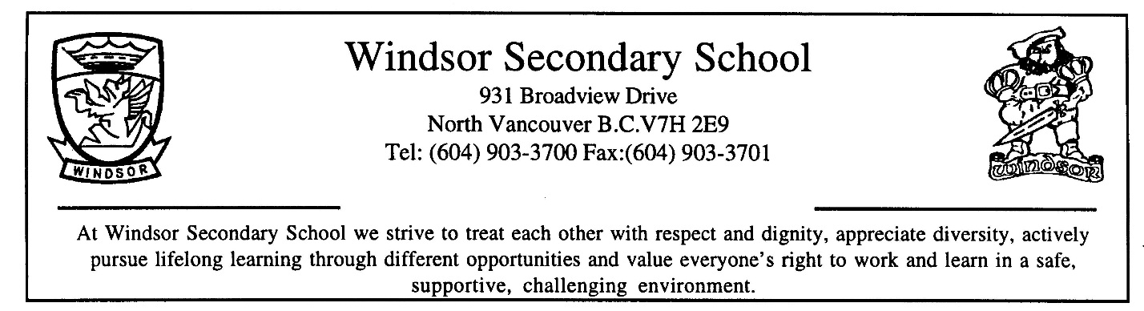

COURSE OUTLINE
SUBJECT: Mathematics 11 Instructor: Dr Didier
BIG IDEAS:
Similar shapes and objects have proportional relationships that can be described, measured, and compared. |  | Optimization informs the decision-making process in situations involving extreme values. |  | Logical reasoning helps us discover and describe mathematical truths. |  | Statistical analysis allows us to notice, wonder about, and answer questions about variation.

Students are expected to be able to do the following:
Reasoning and modeling
· Develop thinking strategies to solve puzzles and play games
· Explore, analyze, and apply mathematical ideas using reason, technology, and other tools
· Estimate reasonably and demonstrate fluent, flexible, and strategic thinking about number
· Model with mathematics in situational contexts
· Think creatively and with curiosity and wonder when exploring problems
Understanding and solving
· Develop, demonstrate, and apply conceptual understanding of mathematical ideas through play, story, inquiry, and problem solving
· Visualize to explore and illustrate mathematical concepts and relationships
· Apply flexible and strategic approaches to solve problems
· Solve problems with persistence and a positive disposition
· Engage in problem-solving experiences connected with place, story, cultural practices, and perspectives relevant to local First Peoples communities, the local community, and other cultures
Communicating and representing
· Explain and justify mathematical ideas and decisions in many ways
· Represent mathematical ideas in concrete, pictorial, and symbolic forms
· Use mathematical vocabulary and language to contribute to discussions in the classroom
· Take risks when offering ideas in classroom discourse
Connecting and reflecting
· Reflect on mathematical thinking
· Connect mathematical concepts with each other, with other areas, and with personal interests
· Use mistakes as opportunities to advance learning
· Incorporate First Peoples worldviews, perspectives, knowledge, and practices to make connections with mathematical concepts
CONTENT:
Students are expected to know the following:
- forms of mathematical reasoning
- angle relationships
- graphical analysis:
  - linear inequalities
  - quadratic functions
  - systems of equations
  - optimization
- applications of statistics
- scale models
- financial literacy: compound interest, investments and loans
RESOURCE MATERIALS:
Foundations of Mathematics 11 Textbook
Locally developed supplemental packages

The objective of the course is not simply to introduce certain mathematical concepts, but also to make you understand and be able to explain them to others. It should also help to improve your problem solving, analyzing, communicating and logical thinking skills. You will learn how to ask questions, to communicate mathematically, and how to present and verify your solutions.
I expect that you are a responsible and reflective learner. I expect that you will attend classes, do homework, and frequently check the course website (on the portal) for updates and new information posted. The curricular competencies will be as important as the content of the course.
I expect that you come to class prepared, so that you can actively participate in problem solving activities during class time. I expect that you will work with your colleagues, share your ideas and ask questions. I expect that you will use the extra help outside of class time as an additional resource if you need help with homework or understanding concepts.
Being prepared for class includes working through practice questions and doing more questions from each page if needed. Reflecting on your work and identifying questions you need to ask is also part of the preparation.

Marks:
Class work | 20%
Project work | 30%
Quizzes | 20%
Tests | 30%
Total | 100%

Ministry Link:
https://curriculum.gov.bc.ca/curriculum/mathematics/9

