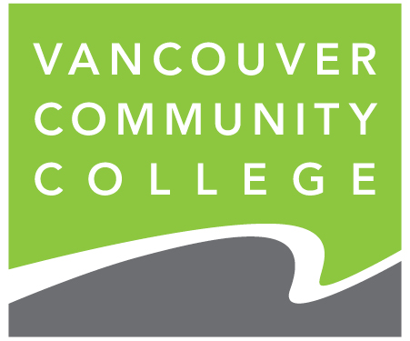

Baking and Pastry Arts Foundation Certificate

High School Youth Train in Trades Program

**Credits:**

Program graduates receive the following:

* **24 High School Credits** applied to graduation requirements
* **24 Post-Secondary Credits** resulting in a Vancouver Community College transcript and a Baking Foundations Certificate
* **Level 1 Apprenticeship Credits**

600 hours technical training and 480 hours work-based training (sponsored by student’s school district) towards the completion of Level 1 apprenticeship requirements.

**Entrance Requirements:**

To be eligible, students must have:

* Foodsafe Level 1
* Strong record of attendance and punctuality
* Grade 10 English Language Arts, Math & Science
* Written reference from teacher or counselor

**Recommended Characteristics:**

* Physical strength and stamina
* Ability to stand for long periods of time
* Previous baking and/or cooking experience
* Strong reading comprehension and study skills
* Time management / multitask skills
* Work independently
* Interest in working with people
* Maturity, interpersonal & communication skills
* Good hand-eye coordination

**Program Costs:**

Youth Train in Trades is a program funded by the Industry Training Authority of BC (ITA).

Students must check with their school or district regarding the portion of costs they are required to pay. Students are eligible for Youth Train in Trades funding.

* Application Fee waived
* Tuition $2,368
* Students’ Union Fee $64
* College Initiative Fee $69
* Graduation Fee $40
* Campus Resource Fee $95
* 6-month U-Pass $266
* Textbooks and tools $1200
* Uniform $262

Tuition and fees are based on December 2023 rates and are subject to change without notice.

Successful applicants will be notified by their school district.

**VCC Baking & Pastry Arts Contacts:**

Laurie Vestergaard, Department Leader

[lvestergaard@vcc.ca](mailto:lvestergaard@vcc.ca)

Kimberly Tada, Instructor

[ktada@vcc.ca](mailto:ktada@vcc.ca)

Tiffany Kang, Program Assistant

[tikang@vcc.ca](mailto:fxue@vcc.ca)

**Program Schedule:**

* **July 08 to December 12, 2024**
* (23 weeks)

**Monday to Thursday**

**11:30 a.m. – 6:30 p.m.**

Classes take place at the Vancouver Community College Downtown campus.

**Progression and Completion**:

Students must achieve 70% in each VCC course and maintain a successful attendance record to receive VCC credits and technical training certification. Students who do not meet the requirements will not be eligible to complete the program and will return to their secondary school.

**Application Procedure:**

1. Prospective students should contact their School District Career Program Coordinator or Administrator to begin the application process.
2. Applicants are required to attend an in-person information session and tour from **5:00 pm to 6:30 pm on Thursday**, **February 22, 2024**. Parents and teachers are welcome to attend.
3. Interviews: **April 29& 30, 2024**
4. Applicants must submit a resume and digital portfolio via their District Coordinator by April 20, 2024

Successful applicants will be notified by their school district.