How to Use LightBox by Follett
- Click on the LightBox link on the Montroyal
Library Home Page
- To Login:
User Name: guest
Password: follett

How to Use e-Books

About eBooks
The reader makes it easy to read Follett eBooks. Follett eBooks open automatically in the reader within Destiny® Library Manager™ and Destiny Discover™.
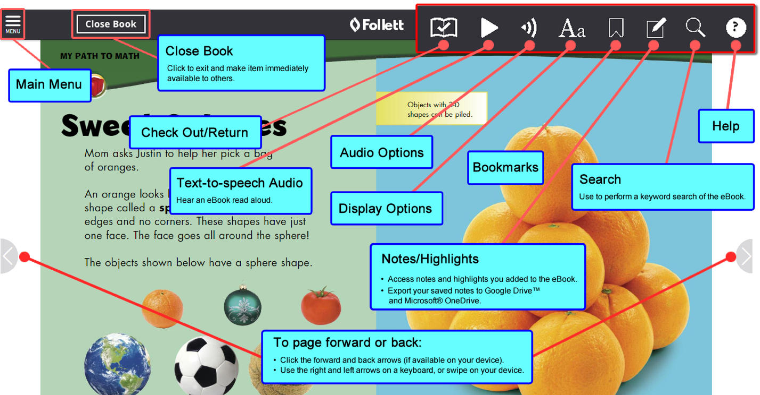

How to Use Audiobooks

About Audiobooks
The reader lets you listen to Follett Audiobooks online. Follett Audiobooks open automatically in the reader within Destiny® Library Manager™ and Destiny Discover™.
