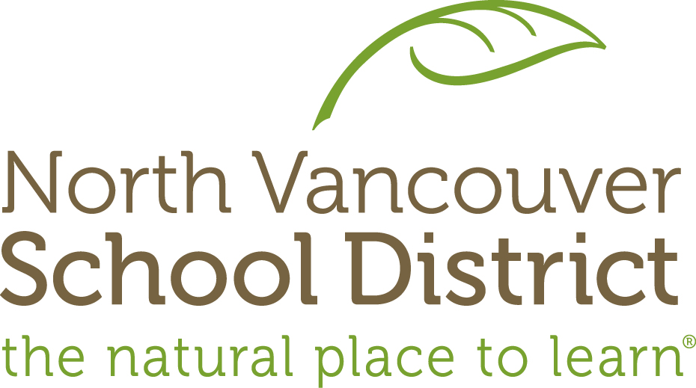

February 2017

RE: Food Access Program

In 1996, the North Vancouver School District (NVSD) created a Hot Lunch Program targeting four elementary schools and was connected to the Ministry program called Community LINK (Learning Includes Nutrition and Knowledge). After reviewing the Hot Lunch programs in the four schools, it was decided to move away from the intensive/targeted support and make food access universal for all schools in NVSD as research continues to show strong links between good nutrition and academic success. As a result, the Food Access Program will be starting at Braemar Elementary the week of March 27, 2017.

The Food Access Program has been running in majority of NVSD elementary schools since 2014. We recognize the value of ensuring students have access to healthy food when they are hungry. Knowing that there are students throughout our entire NVSD who do not have access to regular nutritious food, the NVSD is now expanding its food program. Instead of just operating in four schools, the new Food Access Program will be available in all 31 schools providing access to nutritious snacks whenever students need them.

All school communities are not equal in their level of support required. The demographics of each site vary depending on the clientele and their situations. NVSD gathers information from the Ministry of Children and Families, builds a profile of each school, and places schools into Tiers of Support. The Food Access Response Model has three levels and responds to each level with an increasing intensity in both funding and community partnerships. Most schools in NVSD are situated in this level. Approximately 1 to 3% of their population is described as “vulnerable.” Braemar Elementary falls under this tier and will be placed into the current Food Access Program with limited targeted support starting March 2017.

I hope that our parents will understand the importance and value of the new expanded Food Access Program. Although not intended to replace the healthy snacks and lunches that parents send their children to school with, the Food Access Program allows access to nutritional food all day for every student. Consistent, healthy nutrition is an important factor in every student’s ability to learn, stay focused, and self-regulate. It is wonderful that we are able to offer all students a healthy snack when they need it.

If you have any questions, please do not hesitate to contact me.

Sincerely,

Sanj Johal
Principal, École Braemar Elementary
sjohal@sd44.ca

