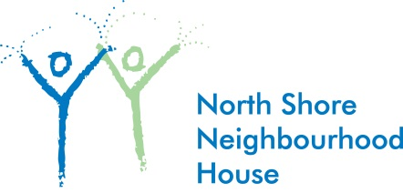

Free

Homework Club in partnership with the NVC library

For grade 4 and 5 students at Queen Mary and Westview schools

Starting: Tuesday’s April 8 until June 10
Time: 3:30-4:30 pm
Where: North Vancouver City Library
To Register contact
Maria Morisseau, Queen Mary and Westview Community Programmer
604-290-2384 or mmorisseau@nsnh.bc.ca.
Complete the Emergency consent form on the back of this flyer and return to Maria

