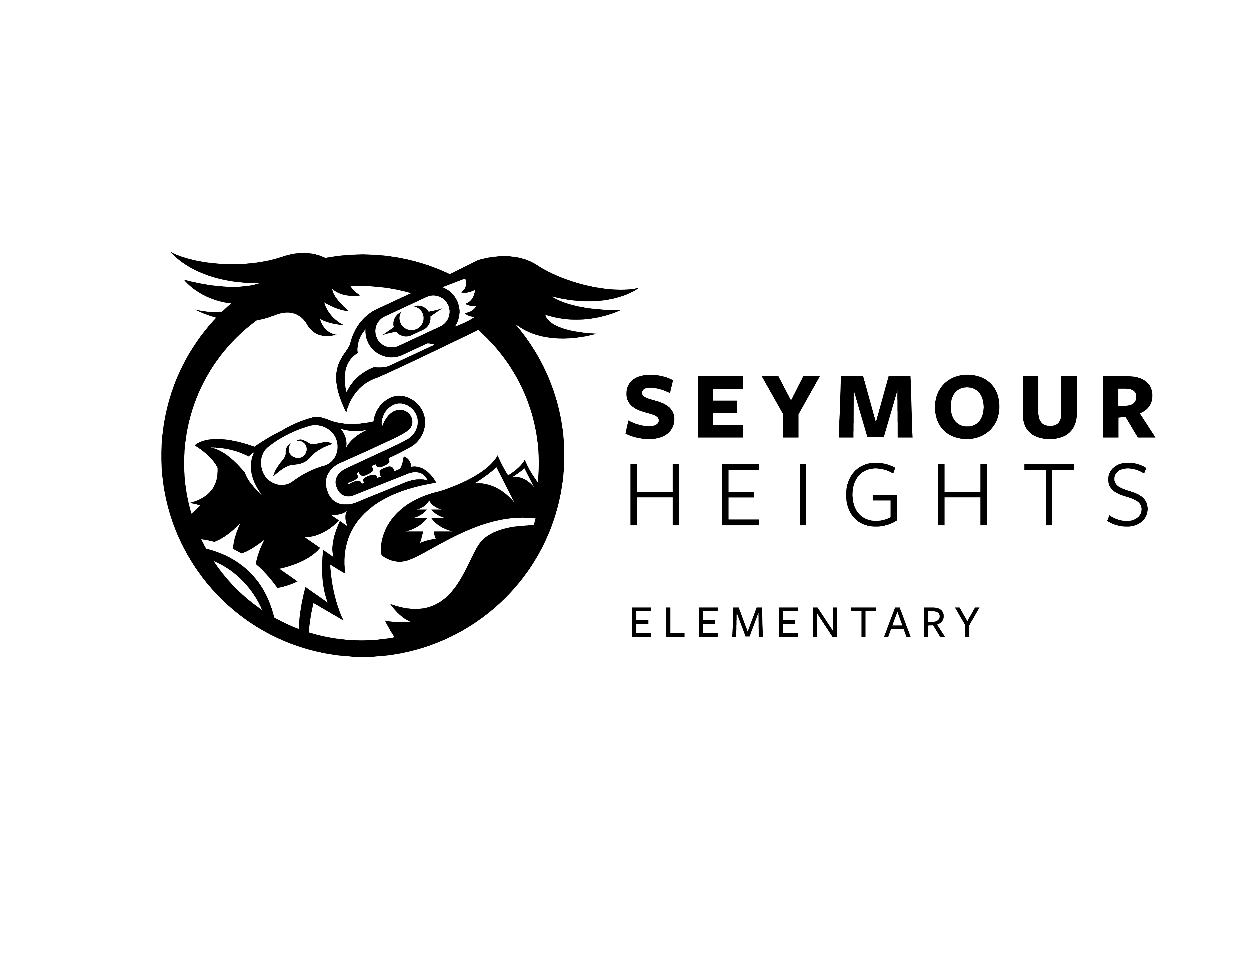
SEYMOUR HEIGHTS CALENDAR 2019/2020
Days of Instruction | 181
Schools open | Tuesday, September 3, 2019
Staff Collaboration – Early Dismissal at 2:00 pm | Wednesday, September 25, 2019
District Wide Non-Instructional Day (Curriculum Implementation) | Friday, October 4, 2019
Thanksgiving Day (Statutory Holiday) | Monday, October 14, 2019
Province-Wide Non-Instructional Day (NVTA) | Friday, October 25, 2019
Remembrance Day Holiday (Statutory) | Monday, November 11, 2019
Staff Collaboration – Early Dismissal at 2:00 pm | Wednesday, November 20, 2019
Last Day for Winter vacation | Friday, December 20, 2019
Winter vacation period (includes New Year’s Day Statutory Holiday) | December 23 to January 3, 2020
Schools reopen after Winter vacation | Monday, January 6, 2020
School Based Non-Instructional Day | Monday January 27, 2020
Staff Collaboration – Early Dismissal at 2:00 pm | Wednesday, January 29, 2020
District-Wide Non-Instructional Day | Friday, February 7, 2020
BC Family Day Statutory Holiday | Monday, February 17, 2020
Schools close for Spring vacation | Friday, March 13, 2020
Spring vacation period | March 16-27, 2020
Schools reopen after Spring Vacation | Monday, March 30, 2020
Easter Holiday (includes Good Friday and Easter Monday) | Friday, April 10 – Monday, April 13, 2020
Staff Collaboration – Early Dismissal at 2:00 pm | Wednesday, April 29, 2020
District – Wide Instructional Day (NVTA) | Monday, May 4, 2020
Victoria Day Statutory Holiday | Monday, May 18, 2020
Staff Collaboration – Early Dismissal at 2:00 pm | Wednesday, May 27, 2020
Last Day for Students | Wednesday June 24, 2020
School Based Non-Instructional Day | Thursday, June 25, 2020
Schools Close for Summer Vacation (Administrative day – Non-Instructional Day) | Friday, June 26, 2020

SEYMOUR HEIGHTS ELEMENTARY SCHOOL FEES 2019/2020
Kindergarten - $57 ($40 for Kindergarten supplies and $17 for school wide program)
Grades 1-7 - $25 ($8 Seymour Heights agenda and $17 school wide program)

Bell Schedule for 2019-2020

8:45 am Doors Open
8:51 am First Bell
8:56 am Final Bell
8:56 am – 10:20 am Morning Classes
10:20 – 10:40 am Recess Break
10:40 – 12:00 pm Morning Classes
12:00-12:30 pm Lunch (play first)
12:30 – 12:50 pm Eat Lunch
12:50 – 3:00 pm Afternoon Classes
3:00 pm Dismissal

