SEYCOVE’S GENDER DIVERSITY & QUEER FESTIVAL
Thursday, April 30, 2015

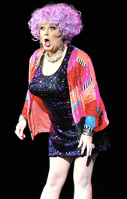
What: A half-day workshop to learn about and celebrate gender diversity. Keynote speaker (Conni Smudge) will kick off the event followed by 2 short-film screenings. The lunch hour includes informational booths, pizza lunch (minimum $5 donation), and entertainment. Participants will then take part in 2 afternoon interactive workshops.

Where: Seycove Secondary School
1204 Caledonia Ave, North Vancouver
Sign in at the front of the school at 11:30am

When: Thursday, April 30, 2015 – 11:50am-3:10pm
For more information, email: brianhwilson@shaw.ca or ayeo@sd44.ca

Who: Any students interested in LGBTQ+ issues

How: Register online at: http://qsa.seycove.ca
Space is limited so register now to avoid disappointment.
Registration closes April 24th

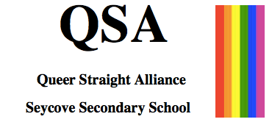
Sponsored by

