

**What’s On**

**@ Cove Cliff**

**Feb 19th – 23rd**

**Reminders/Information:**

* **Wildlife in the neighbourhood!** With ongoing reports of large animals in the area, please remind your children about safety around wildlife, and please be alert as you commute to and from the school. **If you observe any potentially dangerous animals near the school, then please let us know immediately. Please report all dangerous animal sightings to the RAPP line.**

**Always check our** [**online calendar**](https://www.sd44.ca/school/covecliff/Calendar/calendar.aspx#/=) **for upcoming events. Upcoming Events Highlights:**

|  |  |
| --- | --- |
| **Schedule Changes** | **Events** |
| **Feb 28 – 2pm dismissal, staff collaboration**  **March 13 – 2pm dismissal, Celebration of Learning**  **March 15 – April 1st – Spring Break**  **April 2 – School reopens** | **Feb 26 – Gr 6/7 Boys Volleyball game @ Eastview**  **Feb 27 – Gr 6 girls volleyball game @ Eastview**  **Feb 27 – Gr 7 girls volleyball game @ Cove Cliff**  **Feb 28 – PINK Shirt day** |

|  |  |  |  |  |
| --- | --- | --- | --- | --- |
| Monday  February 19 | Tuesday  February 20 | Wednesday  February 21 | Thursday  February 22 | Friday  February 23 |
| BC Family Day – School not in session | **3:30 pm Gr. 6 Girls Volleyball game at Cove Cliff**  **3:30 pm Gr. 7 Girls Volleyball game at Lynnmour** | 8:00-8:40 a.m. Beginning band  8:40-9:20 a.m. Continuing Band  **8:10am Math Club**  K - Grade 2: Ms. Dudley’s classroom  Grade 3 – 5: Ms. Mitchell’s classroom  **3:30 pm Gr. 6/7 Boys Volleyball game at Seymour Heights** | **8:15 am Math Club**  Grade 6: Ms. Robitaille’s classroom  **12:20 – 12:50pm – Skipping Club** | **Naa Sheka Riby-Williams School Visit!** 10:40-11:20 a.m. Beginning band  11:20 – 12 noon Continuing Band  **Hot Lunch Day**  **Hot Dog Day** |

**Keep your WITS about you!**

**Playground Problem Solving**

At Cove Cliff we are helping students with problem-solving on the playground at break times.

The approach that we are using is called WITS, which is an acronym for the steps of the strategy.

If you have a problem, follow these steps in order:

**Walk away** – Did that solve your problem?

If not… **Ignore it** – Did that solve your problem?

If not… **Talk it Out** – Did that solve your problem?

If not… **Seek help** from an adult – Did that solve your problem?

We have reviewed this language with our supervision staff this week, and will continue to teach this in classes and assemblies as we move forward.

We are hoping that families can help support this initiative by discussing this at home, and practice using this language to solve problems that happen away from the school.

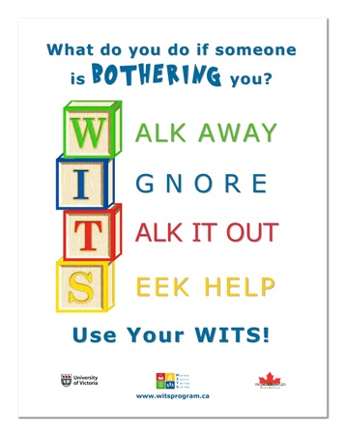.

**Conscious Community Corner**

National Flag of Canada Day — February 15

Did you know that the National Flag of Canada has its birthday today? The Maple Leaf motif of our national flag is 59 years old! Prior to the Maple Leaf, Canada was represented by a few different versions of a flag known as the Canadian Red Ensign.

The rich and fascinating history of the various Canadian flags can be found [here.](https://www.canada.ca/en/canadian-heritage/services/flag-canada-history.html)

The following is a short excerpt from the Government of Canada:

*At the stroke of noon on February 15, 1965, Canada’s red and white maple leaf flag was raised for the very first time on Parliament Hill. On the same day in 1996, National Flag of Canada Day was declared.*

*Our national flag is a symbol that unites Canadians and reflects the common values we take pride in — democracy, inclusion and equity.*

*On February 15, let’s celebrate our Canadian flag!*