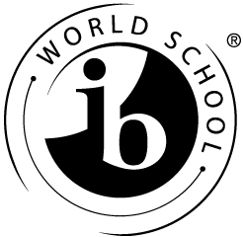

Capilano Elementary School
1230 West 20th
North Vancouver, BC V7P 2B9
604-903-3370

Tuesday, December 11, 2018

Dear Parents/Guardians of Capilano Students,

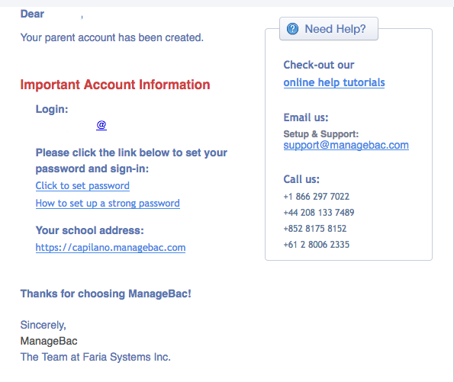
On December 14th parents and guardians will receive an email from Capilano Elementary School through ManageBac. ManageBac is an online system used by teachers to develop and track the Units of Inquiry each grade explores as part of the IB Primary Years Programme. For the 2018/2019 school year, we will also use it to provide digital access to the Student/Family/Teacher conference forms and the Student Self Reflection at the end of May 2019.

Right now, teachers are working hard to upload Student/Family/Teacher conference forms to individual student’s portfolios. Once this process is completed, parents/guardians will receive an email from ManageBac, with instructions on how to set up an account to view your child’s Student/Family/Teacher conference form (similar to the process currently used for accessing the on-line report cards).

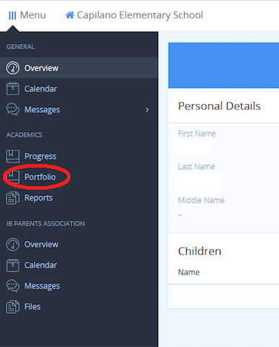
ManageBac is a secure and private system - you will only be able to view your own child’s work. This on-line access also allows for flexibility of viewing from anywhere, as you can login from any device. The Student/Family/Teacher conference forms will be found through the Portfolio on the side menu.

If you have any questions about the use of the ManageBac system, or the online portfolios, please speak to your child’s classroom teacher, or contact our IB Coordinator, David Andrews (dandrews@sd44.ca). Thank you!

Sincerely,
Doug Beveridge
Principal, Capilano Elementary School

