École Boundary School
Weekly Update
for November 27-December 1

Monday  27 | Tuesday  28 | Wednesday  29 | Thursday  30 | Friday  1
Outdoor school forms past due  A 10 minute Ministry survey regarding before and after school childcare being emailed home today – please complete before Dec. 1 | After-school SPORT CLUB  Hot Lunch |  | Purdy’s pick up 2:30-3:30 in fornt of the school

A MESSAGE FROM MS. LAROUE and MS. WARDAS

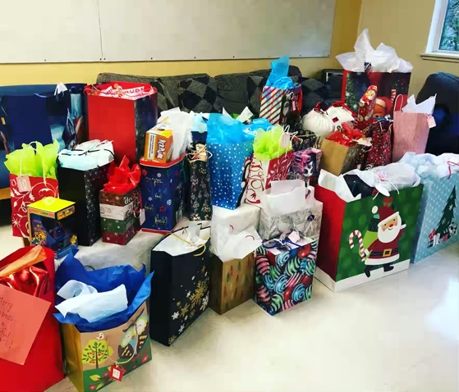
For the last several years Boundary has been a part of something truly wonderful and inspiring for our students, families, and staff. We have become an integral part of delivering holiday joy for the Elizabeth Fry Society Holiday Campaign. We contribute toys and gifts to the Small Frys Toy Bank that ensures every baby, child, and teen has what they need and a special gift to open for the holiday season. If possible, we also try to provide the moms with a holiday treat as well. Classes have different ways of participating in this experience. The students will thoughtfully discuss the kinds of items they think will be most appreciated by the children their class is buying for, first names and ages will be provided. Students may have a specific idea for a gift they want to purchase or bring in cash to pool together to purchase something. Everything donated will be gratefully accepted. Please only new items.
Seeing the generosity and kindness displayed for our community is a very memorable for students, families, and staff.
For more information, please click here: Elizabeth Fry Society https://efry.com

Congratulations to the Boundary Community for raising $949.75 for The Terry Fox Foundation! This is an increase of $174.80 from last year.

Our lessons and learnings with Personal Core Competencies this month continue to bring awareness to knowing ourselves. Knowing yourself so that you can be your own ‘protector’ like Bear, begins with making sure your basic needs are met. We all need healthy food, enough sleep and rest, clean water to drink, regular exercise and the opportunity to play! Think about your daily routine and how you and your family make sure that all of your basic needs are met. We know that less screen time and more time being in nature and / or exercising helps to keep ourselves regulated and focussed.

Please reach out to your child’s classroom teacher at any time if you would like to know more about the work they are doing with Core Competencies or Second Step.

Cold and Flu season is upon us!
Knowing ourselves and our bodies is also a good time to remind parents that if your child is sick, PLEASE keep them home. There has been a significant amount of respiratory/sinus/tummy troubles making its way through the Boundary community. Thank you for keeping your child home until they are 24 hours symptom free. The staff thank you kindly!
Vancouver Coastal Health Info

UPCOMING EVENTS

December 4 Curriculum Day – Schools not in session
December 7 Hanukkah begins
December 13 Band Concert (5:30 student arrival, concert begins at 6pm)
December 19 Primary Winter Concert (date changed – 6pm start)
December 18 Report Cards published
December 20 -22 All Grade 6 Students go to Outdoor School
December 22 Last day of school before the break – PJ DAY!!
December 23-Jan 7 Schools closed for Winter Break

GRADE 7 NEWS

START SAVING YOUR DRINK CONTAINERS!
The Grade 7 Graduating Class of 2024 has started fundraising for their farewell celebrations and will be hosting their first bottle drive. Spread the word and get the neighbours involved too!!

Our first collection date will be Saturday, December 2 between 10am - 3pm at the front Ecole Boundary Elementary in the drop off/pick up zone. This is a drive-by event!
All returnable items are accepted - cans, bottles, juice boxes, milk cartons, etc. If you are unable to attend, we strongly encourage you to use the self-serve at any of the participating Return-It locations. Please visit your closet location and use phone number 604-903-3260 to donate. If you have any questions, please email boundarygrade7grad@gmail.com

School Reminders and Routines
Please help notify Boundary neighbours

We are struggling with an ongoing issue of dogs on the playground and the mess they leave behind. Almost daily, children are stepping in feces on the primary playground and then spreading it to the playground equipment. While we are able to clean up, none of this has been pleasant for staff or students. Please do not allow your dog to run free on the playground and thank you for cleaning up after your pet.

Please communicate absences by school messenger app, email to boundary@sd44.ca & teacher(s) or absence line 604-903-3264

Reminder to check your School Cash Online account for any unpaid items
(school fees are now past due) and to ensure all required online permission forms have been submitted.

Thank you for completing all forms and returning them to your child’s classroom teacher.

NEWS FROM THE SCHOOL DISTRICT

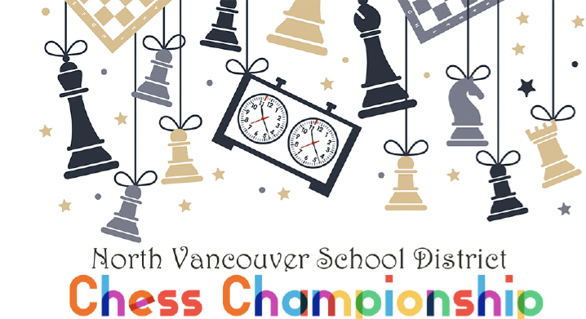
You are invited!
Compete in the 2024 North Vancouver School District Chess Championship.
For NVSD students in Grades K-12, all skill levels and experience are welcome. Compete in one of three divisions (Primary, Inter- mediate and Secondary) for individual and school prizes.
Date: Friday, Febraury 16th, 2024
Time: 9 a.m. to 3 p.m. (check-in begin at 8:15am) Place: Educational Services Centre (2121 Lonsdale Ave)
Free to enter
For more details visit sd44.ca or email: chess@sd44.ca.

PAC NEWS

Engage with us on Instagram and Facebook @boundarypac

Ski Program: After careful consideration, we have decided to cancel the Boundary ski program for a few reasons. We appreciate our community's support and understanding.
LVCA Parade of Trees: We are thrilled to participate in this year's 13th annual parade of trees. Be sure to stop by for the tree lighting on December 3 from 4-5:30 p.m. Thank you to Bailey Environmental Consulting for sponsoring this year's tree.
All I Want for Christmas" Youth to Youth Gift Card Campaign: We are encouraging families who have the means to to support local teens in need this holiday season. Working with the Christmas Bureau, families can purchase a gift card (with an approximate $20 value) to their favourite stores (ex. BestBuy, London Drugs, Sephora, “Happy Teen” gift cards, Park Royal gift cards, and fast-food restaurants such as McDonalds). Please drop gift cards in the PAC MAILBOX (this is the blue wooden box, in the foyer, on the east wall, by the main doors). Alternatively, you can drop off at the Christmas Bureau, where they will be made available to families in their toy shop.
Donations can also be collected using the convenient Youth to Youth QR code. No time limit.
Purdy's Fundraiser: Thank you to everyone who made purchases. Pick-up is on November 30 from 2:30-3:30 at the front of the school in the drop off area. Keep an eye out for a blue CRV!
Pure & Sweet Photography: Thank you to everyone who participated in this fundraiser last month. We are so grateful to Erica for donating her time - please be sure to place your photo orders with Erica in time for the holidays.
Card Project: Orders are now closed. Thank you for your orders. Delivery range is December 4-8.They will be delivered to your child’s class room. So please check their bags.
FreshSchools – Visit boundarypac.ca to sign up for this platform and stay up-to-date on all Boundary-related events.
Hot lunch registration – If you haven’t already, please sign up now . https://boundary.hotlunches.net/admin/ All students must register each year using code BEHL If you have an existing credit, please use the same email and user name. Check out the FAQ at https://boundarypac.ca/support-our-school/hot-lunch/ for important info about ordering, and more.

School Wide Focus

CODE OF CONDUCT

​Caring for Self and Others
Caring for Learning
​Caring for the Environment
SCHOOL GOALS FOR 2023-2024
Goal 1: To develop in students the knowledge skills, and understandings to enable them to be socially, emotionally, and physically healthy
Goal 2: To develop in students the knowledge, skills, and understanding needed to approach and complete tasks and routine, even in the face of change
Goal 3: To develop oral language and reading skills that enable students and families to experience joy, learning, and creativity through language and story

HELPFUL WEBSITE LINKS

North Vancouver School District Website: www.sd44.ca
École Boundary School Website: click here
École Boundary School Plan: click here
Boundary PAC website click here
Argyle School Website: click here

New Reporting resources for parents and caregivers: click here
North Shore Family Services: click here
North Vancouver District Public Libraries: click here
North Vancouver Recreation: click here

