École Boundary School
Weekly Update
for November 20-24

Monday  20 | Tuesday  21 | Wednesday  22 | Thursday  23 | Friday  24
After-school SPORT CLUB

Hot Lunch

A MESSAGE FROM MS. LAROUE and MS. WARDAS

What a beautiful week we’ve had! We are loving the sunshine and crisp mornings. There is definitely a feeling of being “settled in” now, as routines are becoming familiar and incredible work is being done by all students and staff. I don’t want to “jinx” anything… but our next two weeks might be our quietest before the busy-ness of the holiday season approaches! Enjoy!

Over the next few weeks Boundary students may be exploring Personal and Cultural Identity, and Social Responsibility. This Core Competency is about knowing ourselves, knowing who we are, where we come from and how we connect with other people. To learn these things, we need to communicate with others. Communication skills run through all our Core Competency work. A First People’s Principle of Learning is understanding that “learning requires exploration of one’s identity”. Do you know your family history? Can you describe who your family is, where you come from, and what different groups you belong to? Are you an Indigenous person or a Settler? No story will ever be more interesting than your own family story!

Please reach out to your child’s classroom teacher at any time if you would like to know more about the work they are doing with Core Competencies or Second Step.

UPCOMING EVENTS

December 4 Curriculum Day – Schools not in session
December 7 Hanukkah begins
December 13 Band Concert (5:30 student arrival, concert begins at 6pm)
December 19 Primary Winter Concert (date changed – 6pm start)
December 18 Report Cards published
December 20 -22 All Grade 6 Students go to Outdoor School (see below for more info)
December 22 Last day of school before the break – PJ DAY!!
December 23-Jan 7 Schools closed for Winter Break

GRADE 6 OUTDOOR SCHOOL NEWS

Thank you to those parents who joined us last night for the parent information evening.
All forms are now due on Wednesday, November 22nd to accommodate Outdoor School planning guidelines. Thank you for getting your forms in quickly. If you have any further questions, please reach out to your child’s classroom teacher. Thank you!

GRADE 7 NEWS

HOODIES ARE HERE!
Grade 7 students will be getting their hoodies today (if they ordered one!)

START SAVING YOUR DRINK CONTAINERS!
The Grade 7 Graduating Class of 2024 has started fundraising for their farewell celebrations and will be hosting their first bottle drive. Spread the word and get the neighbours involved too!!

Our first collection date will be Saturday, December 2 between 10am - 3pm at the front Ecole Boundary Elementary in the drop off/pick up zone. This is a drive-by event!
All returnable items are accepted - cans, bottles, juice boxes, milk cartons, etc. If you are unable to attend, we strongly encourage you to use the self-serve at any of the participating Return-It locations. Please visit your closet location and use phone number 604-903-3260 to donate. If you have any questions, please email boundarygrade7grad@gmail.com

School Reminders and Routines

Boundary K-3 Multi-Sport After School Program
Dates: Friday, January 12th - March 15th (No Session Feb 16th)
Times: 3:00-4:30
Grades: K-3
Some spots still remaining!
Cost: $300 + GST

This excitement filled program focuses on FUN, physical literacy and sport skill improvement through fun games and activities. Participants will move through a variety of sports such as basketball, soccer, tennis, football, hockey, volleyball, handball, and more. Participants will be fully submerged in the world of sports and are bound to leave the day with a smile on their face, eager for the next day!
NOTE: This is a non-competitive program and is suitable for athletes of any experience or level!
Registration Link: Sign Up Here

Please communicate absences by school messenger app, email to boundary@sd44.ca & teacher(s) or absence line 604-903-3264

Reminder to check your School Cash Online account for any unpaid items
(school fees are now past due) and to ensure all required online permission forms have been submitted.

Thank you for completing all forms and returning them to your child’s classroom teacher.

NEWS FROM THE SCHOOL DISTRICT

Information: erase = expect respect & a safe education

erase is about building safe and caring school communities. This includes empowering students, families, educators and the community partners who support them to get help with challenges, report concerns to schools, and learn about complex issues facing students. erase started in 2004 through the provincial government's Safe, Caring and Orderly Schools Strategy, and has since evolved.

Families are encouraged to review the resources and information found on the erase website with their children, including about online safety, mental health and well-being, substance abuse, bullying, racism, sexual orientation, and gender identity (SOGI) and more. There is also a reporting tool to get help and support.

Starting on November 16, the school district and school websites will feature erase on the homepage rotating banner. We are doing this to increase awareness of this resource. You can expect to see erase shared on school district and school websites periodically throughout the school year.

Should you have any questions or concerns, please speak with your child’s teacher, school counsellor or school administration.

Kindergarten Registration
is now open for the 2024-2025 school year.
Please click here or visit the district website at www.sd44.ca

PAC NEWS

Engage with us on Instagram and Facebook @boundarypac

The White Hatter: NVPAC is holding a virtual presentation with The White Hatter, an internet safety and digital literacy education company. From 6:30-7:30 p.m. on November 22, parents can learn about the consequences of "sharenting" on social media. Register here: https://docs.google.com/forms/d/e/1FAIpQLSfbxOmneAL_AA7_saA6j9JcsYQUlwNmJAs4vJEJ083fovHXMQ/viewform.
“All I Want for Christmas" Youth to Youth Gift Card Campaign: We are encouraging families who have the means to do so to support local teens in need this holiday season. Working with the Christmas Bureau, families can purchase a gift card (with an approximate $20 value) to their favourite stores (ex. BestBuy, London Drugs, Sephora, “Happy Teen” gift cards, Park Royal gift cards, and fast food restaurants such as McDonalds). Please drop gift cards in the PAC MAILBOX (this is the blue wooden box, in the foyer, on the east wall, by the main doors). Alternatively, you can drop off at the Christmas Bureau, where they will be made available to families in their toy shop. Donations can also be collected using the convenient Youth to Youth QR code. NO TIME LIMIT OR CUT-OFF
Ski Program: We have secured our ski program dates at Grouse Mountain! 45 spots will be available for kids in grade 3-5. This program is scheduled to run February 2024. Registration and details coming soon!
Purdy's Fundraiser: This fundraiser is now closed. Thank you to everyone who made purchases. Pick-up is on November 30 from 2:30-3:30 ** Pick up will be at the front of the school in the drop off area. Keep an eye out for a blue CRV!
Pure & Sweet Photography: Thank you to everyone who participated in this fundraiser last month. We are so grateful to Erica for donating her time - please be sure to place your photo orders with Erica in time for the holidays.
Card Project: Orders are now closed. Thank you for your orders. Delivery range is December 4-8. They will be delivered to your child’s class room. So please check their bags.
Grit in Schools: Thank you to the team from Grit for leading our kids through a series of excellent workshops to boost brain-health and resilience. These workshops will continue through mid-November, and we hope students are enjoying them.
FreshSchools – Visit boundarypac.ca to sign up for this platform and stay up-to-date on all Boundary-related events.
Hot lunch registration – If you haven’t already, please sign up now . https://boundary.hotlunches.net/admin/ All students must register each year using code BEHL If you have an existing credit, please use the same email and user name.

School Wide Focus

CODE OF CONDUCT

​Caring for Self and Others
Caring for Learning
​Caring for the Environment

SCHOOL GOALS FOR 2023-2024
Goal 1: To develop in students the knowledge skills, and understandings to enable them to be socially, emotionally, and physically healthy
Goal 2: To develop in students the knowledge, skills, and understanding needed to approach and complete tasks and routine, even in the face of change
Goal 3: To develop oral language and reading skills that enable students and families to experience joy, learning, and creativity through language and story

Community News

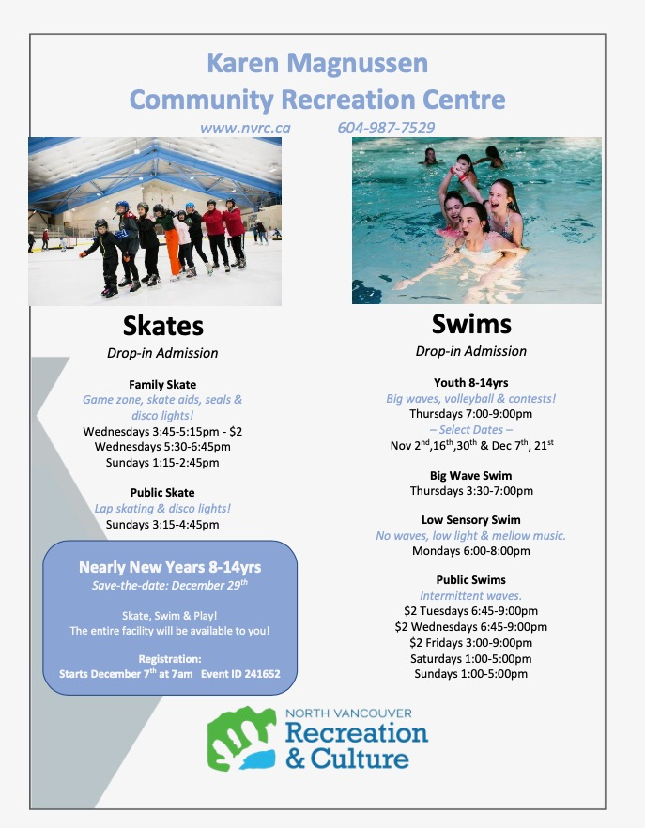

HELPFUL WEBSITE LINKS

North Vancouver School District Website: www.sd44.ca
École Boundary School Website: click here
École Boundary School Plan: click here
Boundary PAC website click here
Argyle School Website: click here

New Reporting resources for parents and caregivers: click here
North Shore Family Services: click here
North Vancouver District Public Libraries: click here
North Vancouver Recreation: click here

